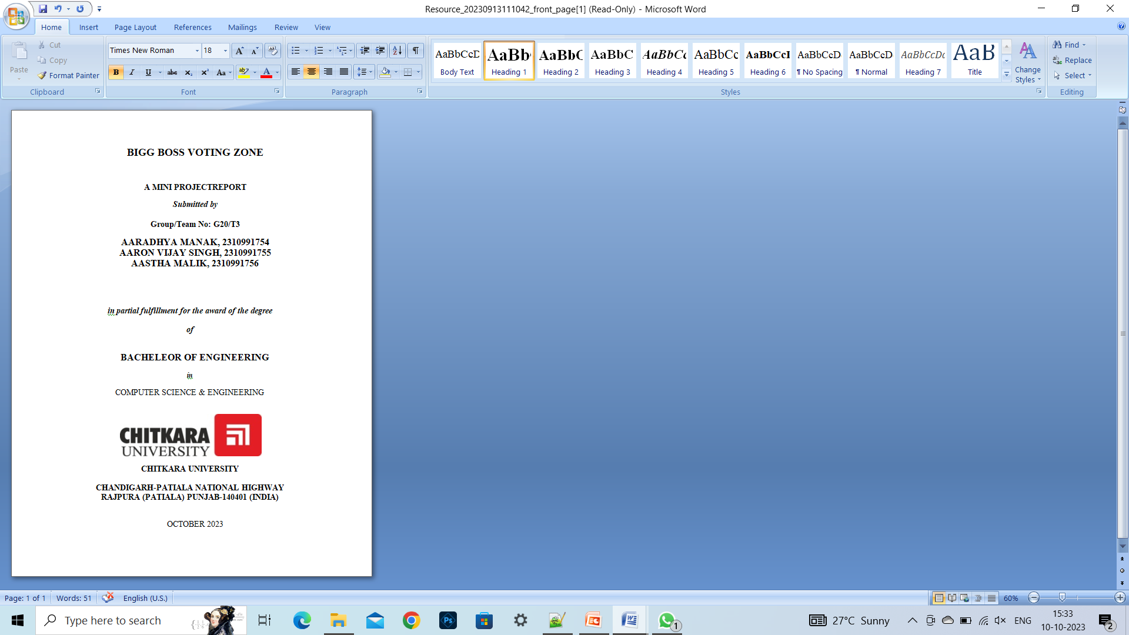

###### TABLE OF CONTENTS

|  |  |  |
| --- | --- | --- |
| Sr.no | Section | Page no |
| 1 | Introduction | 1 |
| 2 | Problem Statement | 1 |
| 3 | Technical Details | 1 |
| 4 | Key Features | 4 |
| 5 | Project Highlights | 5-14 |
| 6 | Conclusion | 15 |
| 7 | References/ Links used | 16 |
| 8 | Thank You | 17 |

1. **Introduction**

TITLE: Bigg Boss Voting Zone

PURPOSE AND DETAILS:

This project is a Html and CSS based ‘Bigg Boss Voting Zone’ that allows the user to vote for their favourite contestant in an interactive and easy form. It’s core purpose is to make voting for audience interesting ,easy and effortlessly.

1. **Problem Statement**

A voting platform is to be designed to show the increase/decrease in the votes of particularcontestant using html and css.

The platform should look quite dynamic to show the progress bars of each contestant.

1. **Technical Details**

HTML AND CSS BASED VOTING ZONE:

* Software used:Notepad++
* Basic html knowledge regarding interlinking,

creating classes, use of div tags,etc.

* Basic CSS knowledge regarding animations,padding,types

of CSS,textmodifications,etc.

1. **Key Features**

* Bigg Boss cover page and its ott logo to give a sense of security in minds of the users.
* Navigaton buttons given to navigate between different webpages through interlinking.
* The ‘User Details’ page is assigned to collect the user info of the voters.
* Animations are used on the Contestant page to make it look professional and skillful.
* Thanks page to assure the voters that their vote has been registered.
* Results page to display the result.

1. **Project Highlights**

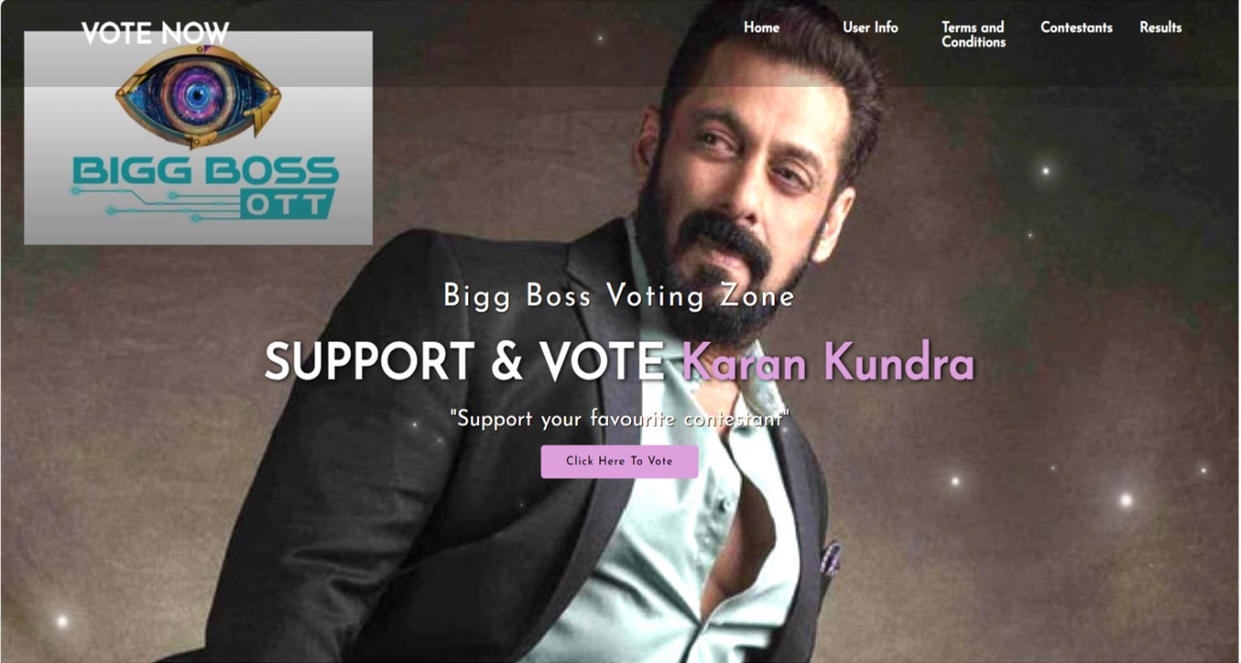

First Page

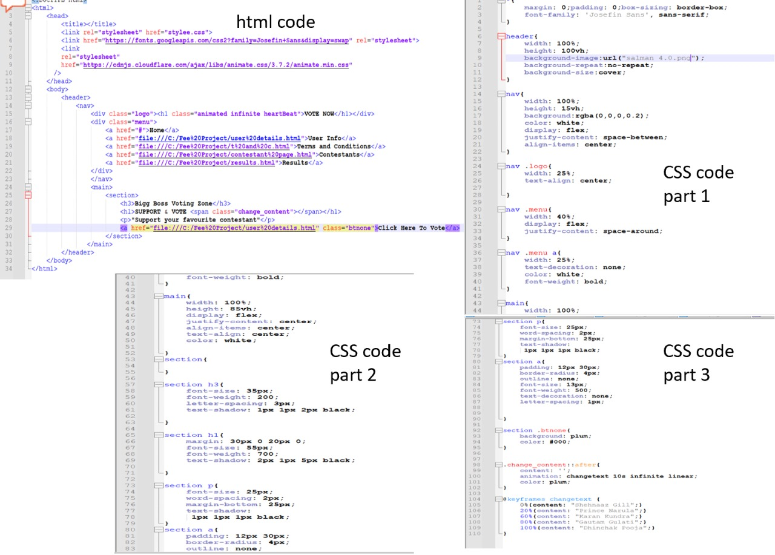

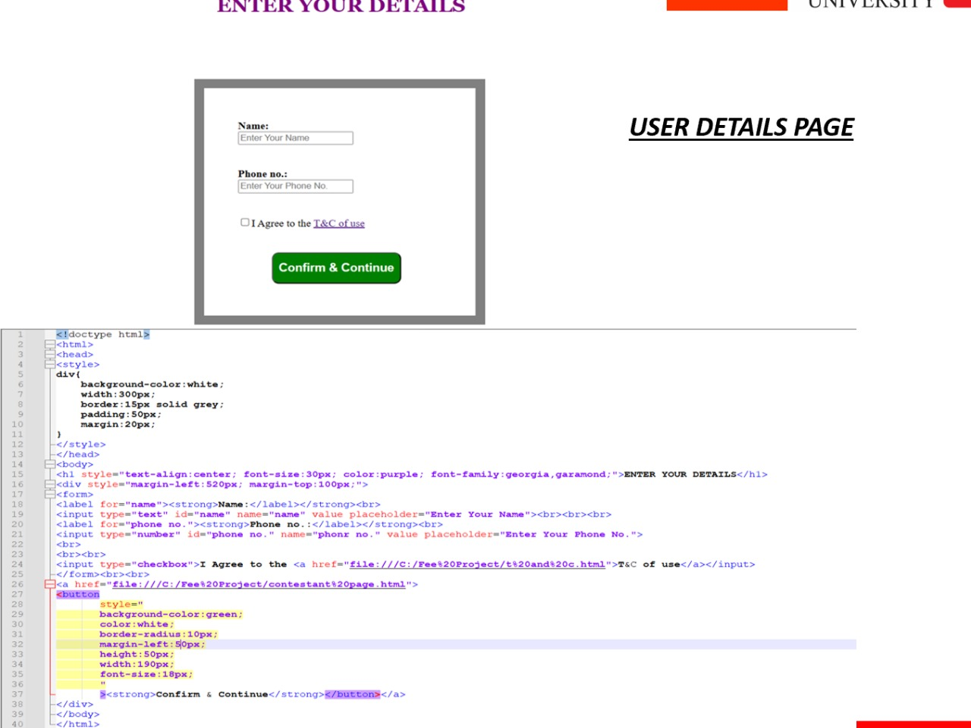

TERMS AND CONDITIONS

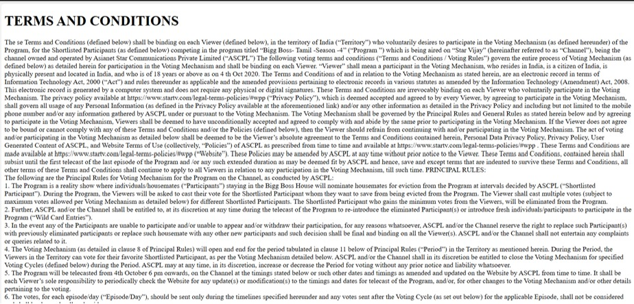

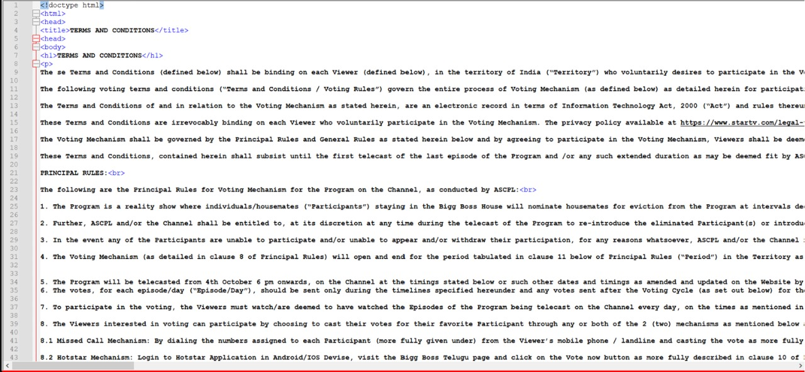

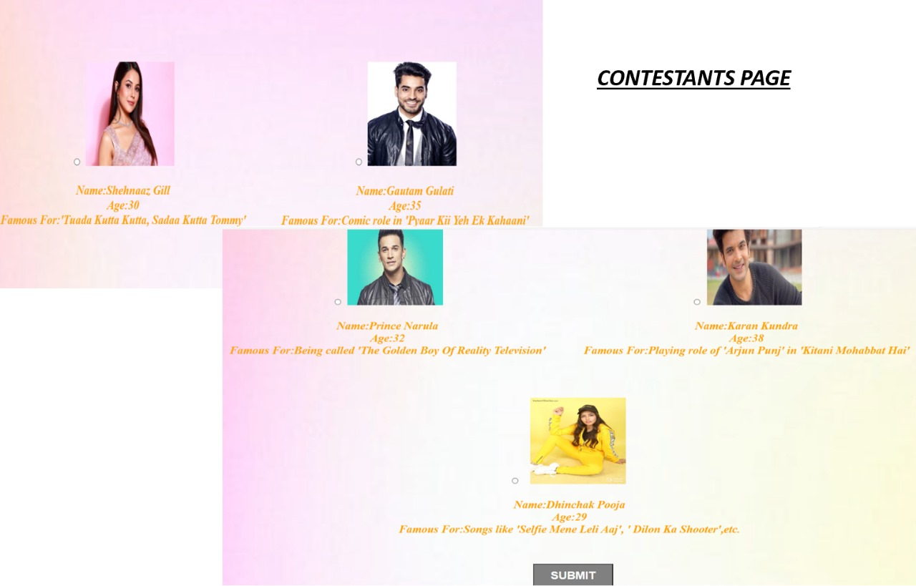

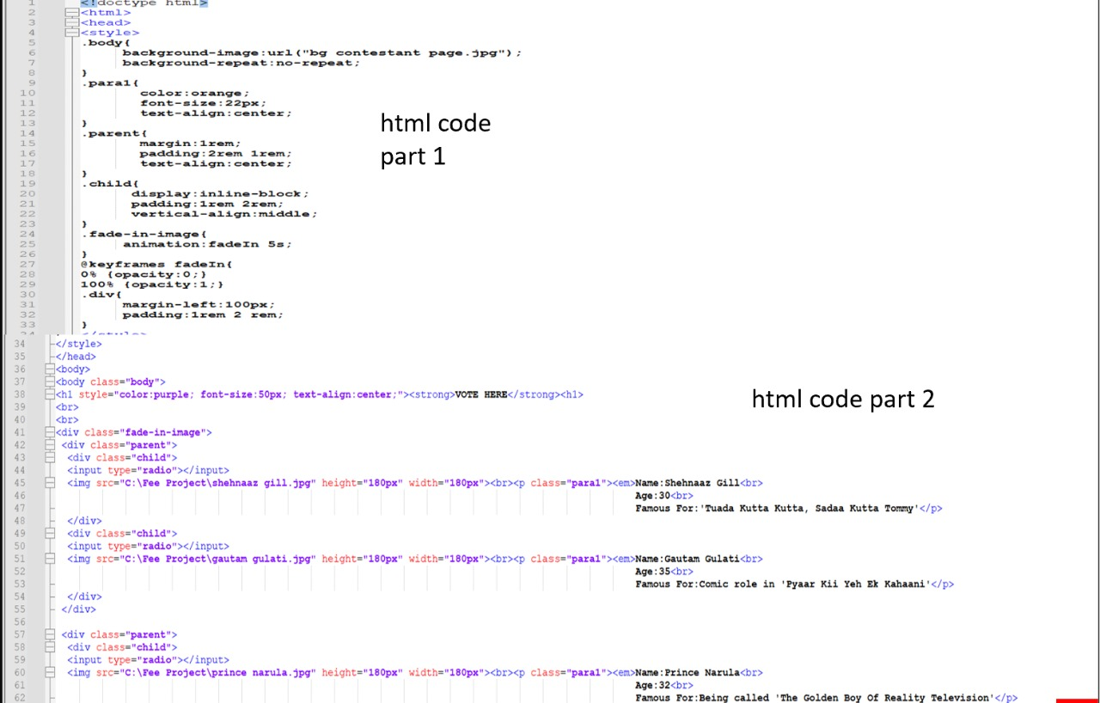

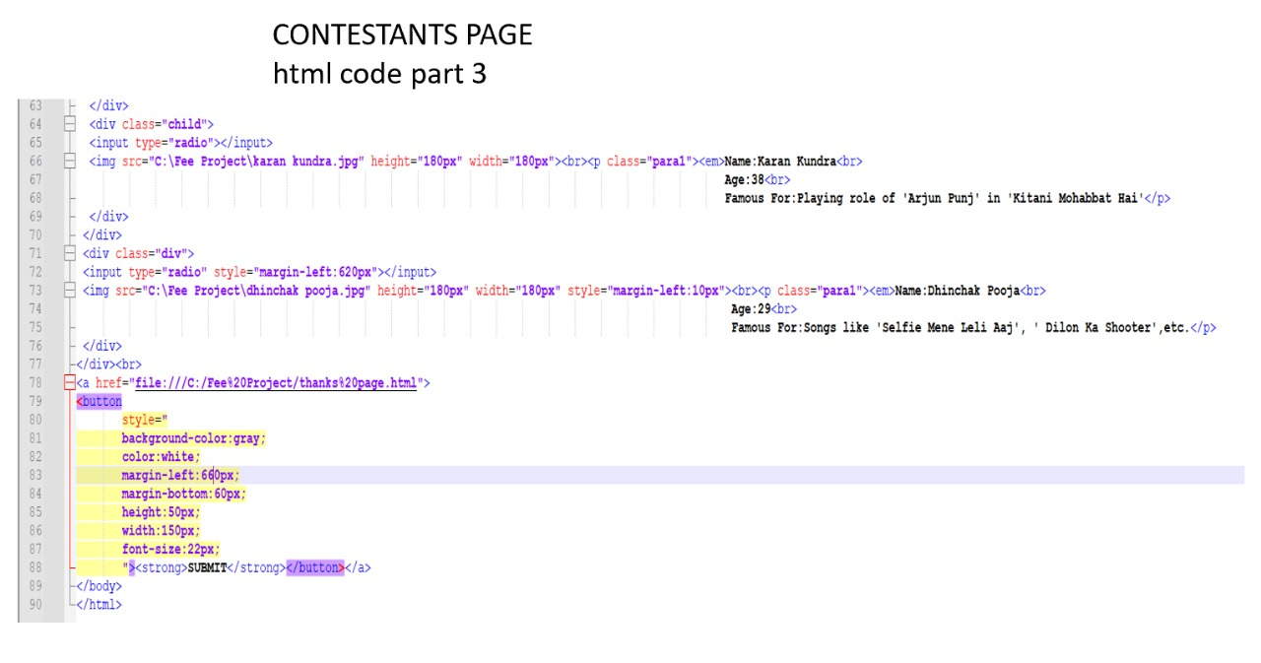

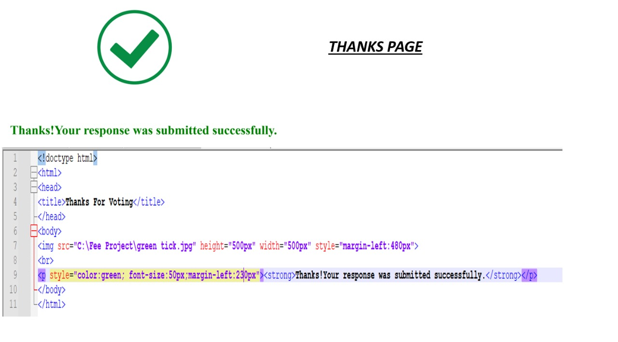

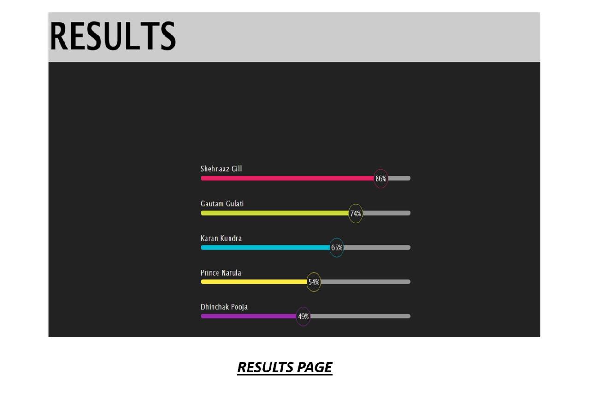

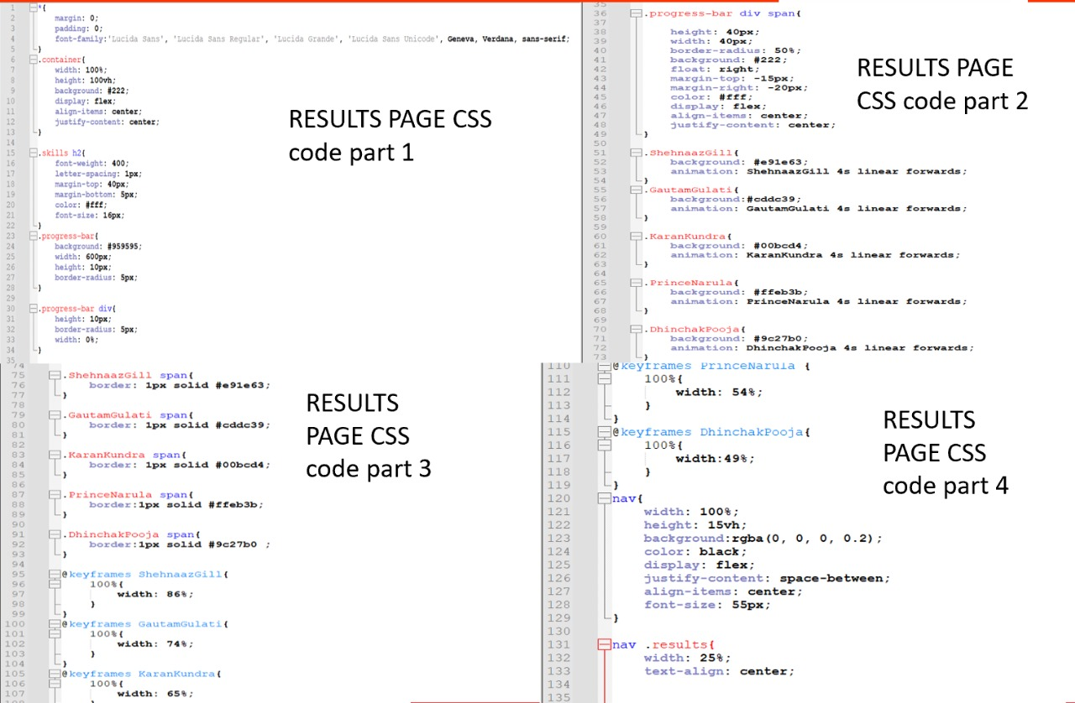

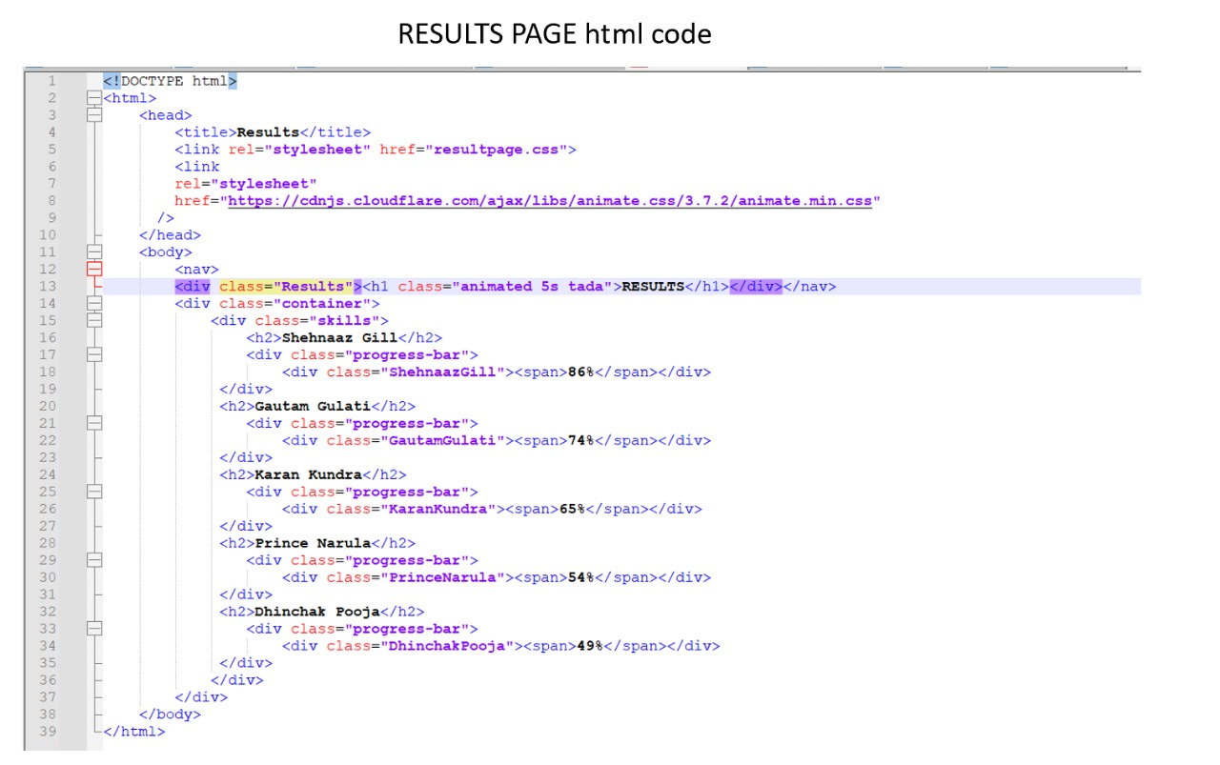

1. **Conclusion**

The project is made using different tags of html, different styles of CSS,their co-relation with each other,so our major takeaways are the use of these tags and properties and become familiar and comfortable with them**.**

1. **References/Links used**

* https://fonts.googleapis.com/css2?family=Josefin+Sans&display=swap
* https://cdnjs.cloudflare.com/ajax/libs/animate.css/3.7.2/animate.min.css
* W3Schools
* Youtube
* Google

